Spanish 1 PL Final Project-Due June 6th
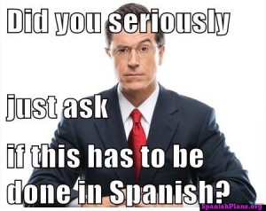
https://mrsespanish.weebly.com/

Objective: SWBAT apply what they have learned during the year in Spanish 1, and will be able to create a final project of their choice using either video clips, or photos. The final projects will be shared and peer evaluated as a class. The vocabulary that you should use is listed on my website, under the vocabulary section. Every chapter has the vocabulary list included, that you can use or print out to use as a reference.
Project Options:
-Make a music video to one of the Spanish songs we have sung in class.
-Create a short video demonstrating 30 vocabulary words. This can be done in school or outside of school
-Create 30 slides using verbs or high frequency vocabulary from the curriculum. These may be done as pictures (Snapchat) or as small video clips demonstrating the vocabulary word.
-Draw or design 30 pictures that demonstrate high frequency verbs or vocabulary.
You may also develop your own proposal/idea. This needs to be discussed with me, and presented prior to working on it.

